Cabramatta Golf Club

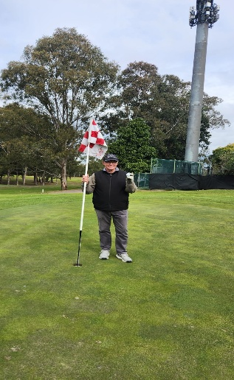
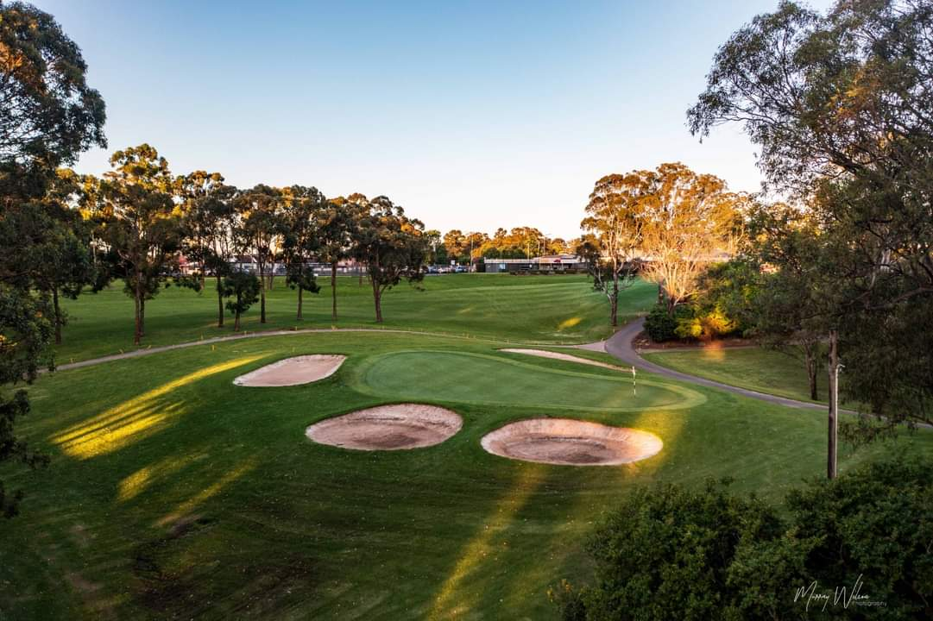
Cabramatta Golf Club
Greg Tracey Saturday, 1st August 2026
Hole In One 16th Hole - 123mtrs

