Working Bee
Working Bee

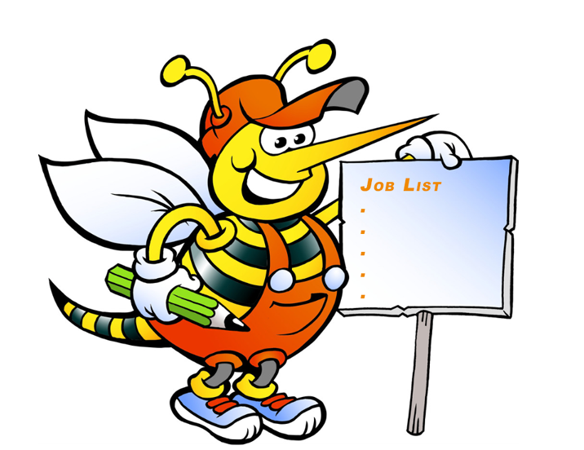`
Monday 19th January 2026
11am meet at the greenkeepers shed.

We need all the help we can to clean the course.
Sandwiches and refreshments supplied.

