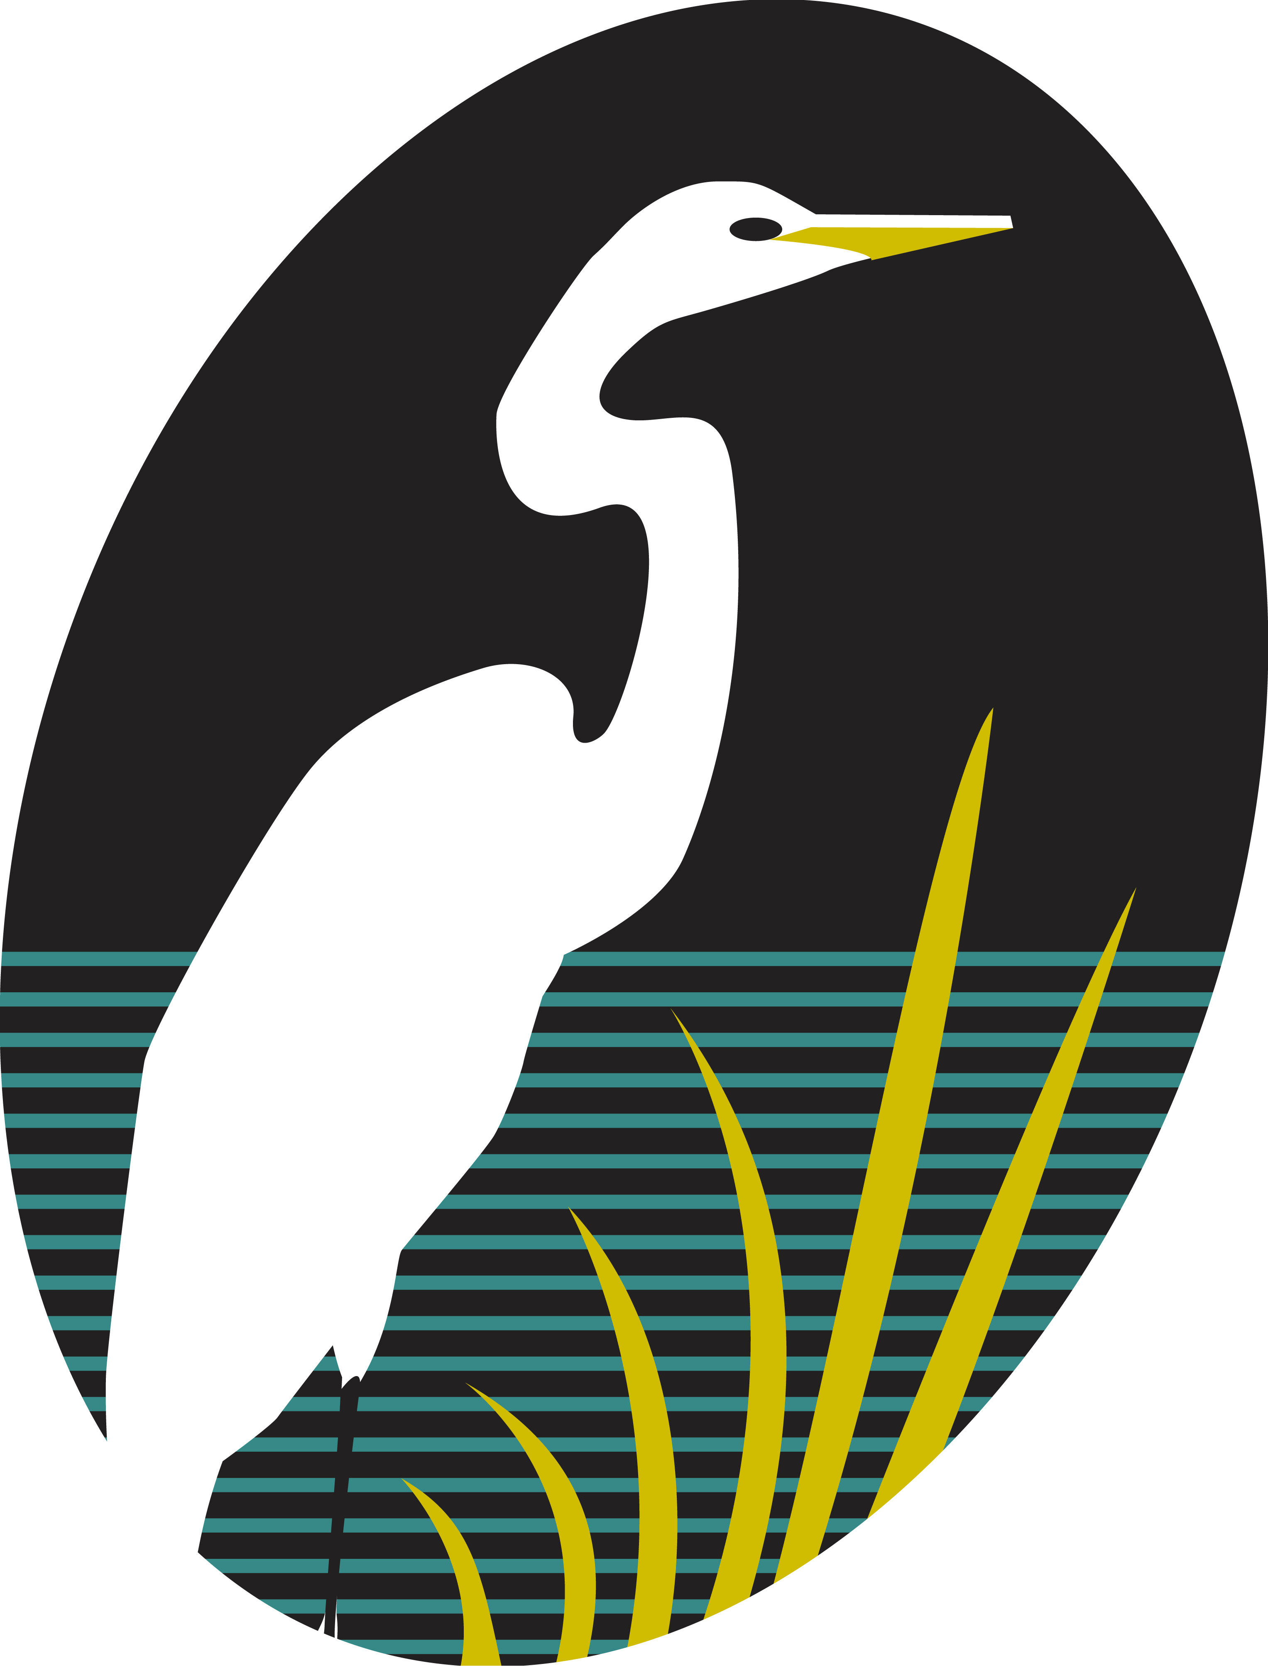

CABRAMATTA GOLF CLUB LTD

Office Bearers for 2024/2026

President: | RAY WILSON
Vice Pres: | PAUL DEXTER
Captain: | SERGE HILANEY
Directors: | TONY HAINING  GEORGE STAFFORD  RICHARD DIGGES  WAYNE PARK
Treasurer: | ILIJA BICANIC

